Premier Insulation West Auckland
and Rodney
Address: Unit 5 184 McLeods Rd
Mike 021 846 482

16/09/2025

Dear Cody McCutcheon,
Re: Independent Insulation Assessment – 3 COLLINGWOOD ROAD, Waiuku 2123
The Residential Tenancies Act Amendment requires all Landlords to make a statement in the tenancy agreement on the details about the insulation installed in their residential property and sets out minimum standards for insulation to be met by the July 2019 Residential Tenancies Regulations and the Healthy Homes Standards Regulations.
As requested, we have completed an insulation quality assessment on the property and provide the following report for your consideration.
Date of Assessment | 16/09/2025
Assessors Name | Percy Darabna
Areas | Description of Insulation | Pass/Fail
Ceiling | Premier G/W Ceiling Segment R3.6 430mm | PASS
Underfloor | Premier Polyester R2.0 Underfloor Blanket | PASS
External Walls |  | EXEMPT
Ground Moisture Barrier |  | EXEMPT
Comments/Notes | Ceiling and Underfloor have been installed and are a pass.  GVB hasn't been done as the perimeter is an open slat construction.

This property meets the Residential Tenancies Act Regulations for insulation. No further work is required.
For more information on our company please visit: www.premierinsulation.co.nz

Yours Sincerely,
Premier A Grade Insulation Limited

Percy Darabna
Premier RTA Assessors
percy@premierwest.co.nz
+64210686083

Insulation Requirements for Landlords under the Residential Tenancies Act
By 1 July 2019 all remaining residential rental properties covered by the RTA must meet the new insulation requirements.
Landlords are required to make a statement in the tenancy agreement on the extent of and details about the insulation installed in their residential property. In order to make this statement, landlords will need to check and confirm what insulation is installed in their rental property. If the existing insulation does not meet the minimum thermal requirements (expressed in R-values) specified in the regulations, or is incomplete, damaged or damp, landlords will need to either replace the existing or install new insulation in the ceiling and underfloor to meet the current Building Code requirements.
Rental properties must have ceiling and underfloor insulation that, at the time of installation, would have met or exceeded the 1978 Standard Permitted Combinations for Type A Construction (NZS4218P:1977).
Ceiling insulation must cover all spaces used for daily activities, excluding clearance required around downlights and flues (areas with habitable space above is exempt from requiring insulation. Where there is existing insulation, it must be in reasonable condition, complete, undamaged and dry.
A suspended floor must have underfloor insulation which is complete, undamaged and dry. It must cover all habitable spaces (a concrete slab-on-ground floor, or floors with habitable space below are exempt. Where there is existing insulation, it must be in good condition, complete, and damaged or damp insulation must be replaced.
All insulation retrofitted or installed in rental properties after 1 July 2016 must be installed in accordance with the New Zealand Standard Energy Efficiency NZ4246:2016 Installing Insulation.
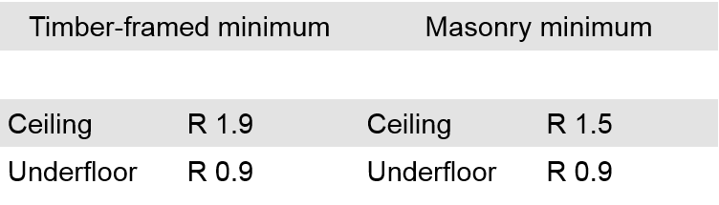
Existing rental properties that already have insulation installed must be upgraded if the ceiling and underfloor insulation does not meet the R-value levels set out in Table 1 below.
Table 1 Level of Insulation below which rental properties must be upgraded (Product R-values)
These R values are roughly equivalent to those that applied for new buildings in the 1978 minimum thermal requirements (NZS4218P:1977). If your property was built after 1978 and complied with the minimum insulation requirements at the time they were built the property will comply, provided the insulation is in reasonable condition. This includes properties where the Verification Method or Alternative Solutions were used.
Existing rental properties which currently have no insulation in the ceilings and under floors must have new insulation installed in these places.
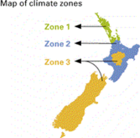
The new insulation must meet minimum requirements that are benchmarked on the current Building Code (H1/AS1) requirements for ceilings and underfloor areas (noted in Table 2 below).
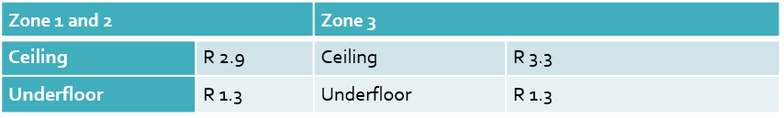
Table 2 Minimum requirements for new and topped up insulation in rented homes (product R-values)
For properties that do not have ceiling and underfloor insulation that meets the R-value requirements in Table 1, new ceiling and underfloor insulation must be installed that ensures the total level of insulation in the ceiling and underfloor meet (or exceed) the minimum thermal requirements in Table 2. The installation of electrically conductive insulation products (such as reflective foil products)will be banned by the regulations.
The ceiling insulation in these properties would need to be replaced if it is excessively compressed, damp or damaged; or have a “top-up” where new insulation is installed over the existing insulation if it is still in reasonable condition.
There are three exclusions:
- When it’s not practical to retrofit insulation because of the physical design or construction of the property until access to these spaces is gained.
- When a landlord intends to demolish or substantially rebuild within 12 months of the commencement of a tenancy, and can provide evidence of having applied for the necessary resource consent and/or building consent for the redevelopment or building work.
- A time-limited exemption (12 months from the date of purchase) from the date of purchase, where a property is purchased and immediately rented back to the former owner-occupier.
The regulations will require that ceiling insulation must cover all applicable habitable spaces. A suspended sub-floor must have underfloor insulation in reasonable condition covering all applicable habitable spaces. However, if there is a property above that is insulated at or above the minimum requirements in the regulations then then the landlord does not need to insulate the ceiling of the property below.

For more Information: https://www.tenancy.govt.nz/healthy-homes/insulation-standard/?gclid=EAIaIQobChMIz-Hj9cnV7AIVRFRgCh0P1QN9EAAYAiAAEgKN7vD_BwE

